|  |
| --- |
|  |
|  |

|  |  |  |  |  |  |
| --- | --- | --- | --- | --- | --- |
| REVISION HISTORY | | | | | |
| Ver. | Description of Change | Author | Date | Approved | |
| Name | Effective Date |
| 1.0 | Initial status | [Kiryl Bucha](mailto:Kiryl_Bucha@epam.com) | 12-JAN-2012 |  |  |
| 2.0 | Added information according to the task | [Hanna](mailto:Elias_Nema@epam.com) Klimovich | 10-NOV-2017 |  |  |

Contents

1. Data Modeling Task 3

2. Analytical task 3

3. Results 3

# Data Modeling Task

As far as TIME is very special dimension, it would not be populated from the normalized layer. Instead it would be populated once in a lifetime. Your task would be to create script for DIM_TIME_DAY (_MONTH, _MINUTE dependent on the time granularity your business process need) and to populate it with data.

SQL:

CREATE TABLE DateDim as

select sysdate+rownum-365*10 as FullDate, extract(month from sysdate+rownum-365*10) as month, extract(year from sysdate+rownum-365*10) as year, extract(day from sysdate+rownum-365*10)as day,

to_char(sysdate+rownum-365*10-1, 'D') as DayofWeek,

to_char(sysdate+rownum-365*10, 'DAY', 'NLS_DATE_LANGUAGE=ENGLISH') AS D_Eng, to_char(sysdate+rownum-365*10, 'DAY', 'NLS_DATE_LANGUAGE=RUSSIAN') AS D_Rus,

to_char(sysdate+rownum-365*10, 'DAY', 'NLS_DATE_LANGUAGE=SPANISH') AS D_Esp, to_char(sysdate+rownum-365*10, 'DAY', 'NLS_DATE_LANGUAGE=GERMAN') AS D_Ger,

to_char(sysdate+rownum-365*10, 'MONTH', 'NLS_DATE_LANGUAGE=ENGLISH') AS M_Eng, to_char(sysdate+rownum-365*10, 'MONTH', 'NLS_DATE_LANGUAGE=RUSSIAN') AS M_Rus,

to_char(sysdate+rownum-365*10, 'MONTH', 'NLS_DATE_LANGUAGE=SPANISH') AS M_Esp, to_char(sysdate+rownum-365*10, 'MONTH', 'NLS_DATE_LANGUAGE=GERMAN') AS M_Ger,

to_char(sysdate+rownum-365*10, 'DDD') AS DayofYear, to_char(sysdate+rownum-365*10, 'IW') AS WeekY, to_char(sysdate+rownum-365*10, 'Q') AS Quarter,

to_char(sysdate+rownum-365*10, 'W') AS WeekofMonth

from dual

connect by rownum <= 365*100;

# Analytical task

Create high-level data-model for the 3NF level. Use a previously created dimensional model as a reference.

* 3NF layer of your Data Warehouse for your business.

3NF layer:

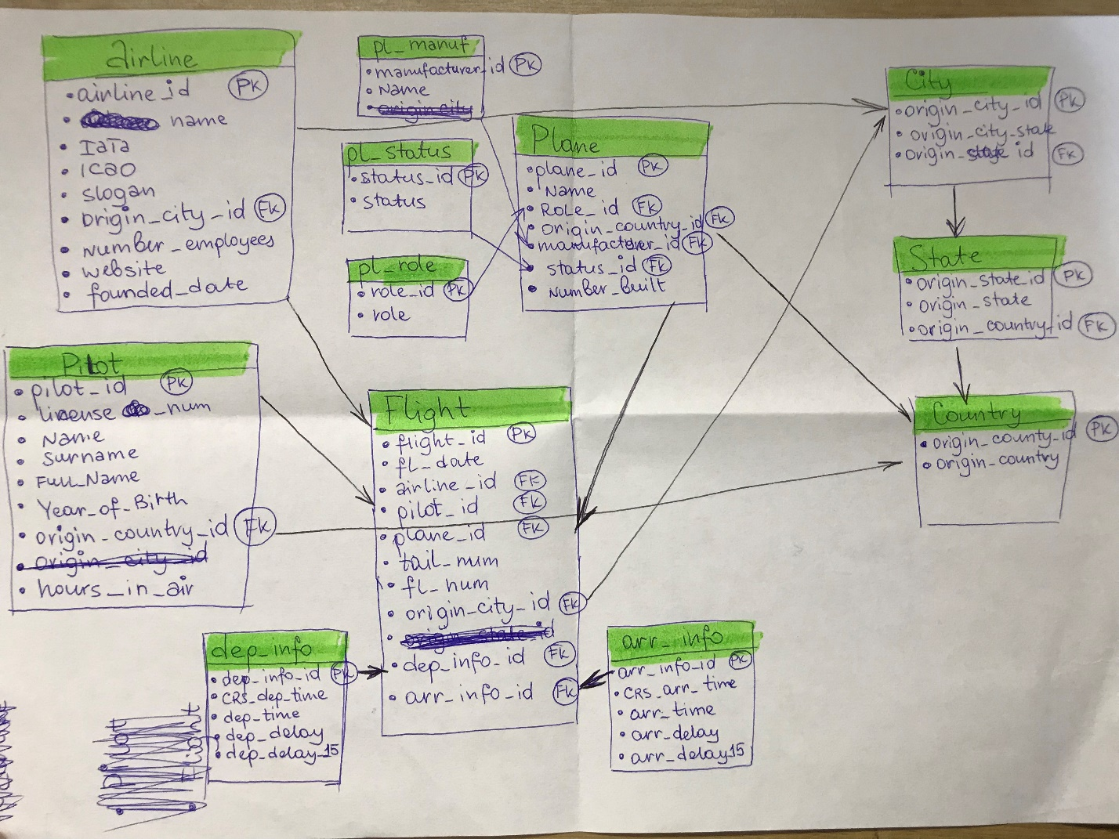

# Results

Result of this lab work should be:

* Scripts for creating a time dimension.
* Chapter in document with the 3NF model and design process.